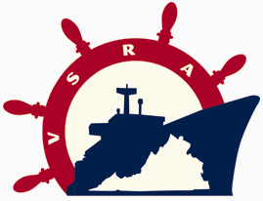 **Application Form**
Virginia Ship Repair Foundation (VSRF)

21st Annual Golf Tournament
Tuesday, August 21, 2007

PLEASE NOTE: All proceeds to benefit VSRF, a 501(c)(3)
Educational Foundation and are Tax Deductible

Where: Bayville Golf Club, 4137 First Court Road, Virginia Beach

Registration: 10:00 to 12:30……..Lunch Begins: 11:00…………Tee Time: 12:30

Choose Level of Sponsorship (guaranteed placement):
Platinum Sponsor- $5000 (includes 2 foursomes, mulligans, banner with logo, featured website sponsorship)
Gold Sponsor- $2500 (includes 1 foursome, mulligans, banner, featured website sponsorship)
Silver Sponsor - $1250 (includes 2 golfers, mulligans, banner, featured website sponsorship)
Hole Sponsor - $500 (signage, program recognition)
Beverage Cart Sponsor - $500 (small banner)
Longest Drive Sponsor - $400 (signage)
Closest to Pin Sponsor - $400 (signage)
Individual Player - $150

DEADLINE FOR ENTRY – August 10, 2007

COMPANY NAME: ______________________________________________________

Primary POC: _________________________ e-mail: _____________________ tel: _____________________

Player Names: 1. 3.
2. 4.
To register complete and return to either:
email: janderson@virginiashiprepair.org Please make checks payable to:
email: ahowell@virginiashiprepair.org Virginia Ship Repair Foundation (VSRF)
150 Boush Street, Suite 802
Chairperson/Primary POC: Norfolk, VA 23510
Leigh Kennedy, email: lkennedy@earl-ind.com Phone: (757) 233-7034
Phone: (757) 215-2550

